Keywords:34ZS21-40,Three-position four-way control valve,34ZS21,40
Beijing BPM,Beijing Petroleum Machinery Co.,Control System for Surface Mounted BOP Stacks, bop control unit, koomey unit, BPMF BOP CONTROL, accumulator unit, FKDQ1200-9,FKDQ1200-9B,FKDQ960-7,FKDQ640-7,FKQ1440-14,FKQ1200-9,FKQ1280-8,FKQ960-8,FKQ840-8,FKQ800-8,FKQ1280-7,FKQ1200-7,FKQ800-7D,FKQ800-7E,FKQ800-7F,FKQ800-8G,FKQ800-9H,FKQ640-7,FKQ800-6FFKQ720-6,FKQ640-6G,FKQ640-6,FKQ640-6M,FKQ640-6S,FKQ480-5,FKQ480-5C,FKQ480-5E,FKQ480-5B,FKQ480-5D,FKQ320-4B,FKQ3204E,FKQ320-4G,FKQ320-3,FKQ160-4W,FK250-4,FK240-4,FK160-4,FK100-4,FK240-3E,FKQ240-3D,FK240-3,FK125-3,FK125-3B,FK125-2D,FK125-2F,FK50-1

Product name:Three-position four-way control valve
Model:34ZS21-40
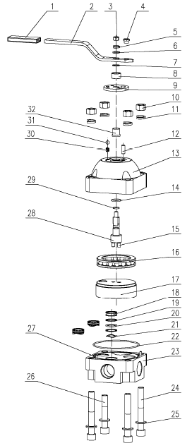
SN NAME ORDER NUMBER QUANTITY REMARKS
1 Handle rubber cover 9160901003 1
2 Handle body 9160901002 1
3 Hexagonal nut 4204000070 1 M12
4 Handle steel cover 9160901001 1
5 Spring washer 4205030060 1 12
6 Flat washer 4205010060 1 12
7 Steel wire retaining ring 9160900012 1
8 Bushing 9160900002 1
9 Locating board 9160900011 1
10 Hexagonal nut 4204000110 4 M20
11 Spring washer 4205030100 4 20
12 Cylindrical pin 4207010120 1 12×30
13 Valve cover 9165600002 1
14 O-ring 5303001110 1 28×3.5
15 Cylinder pin 4207010110 2 10×20
16 Bearing 4301001510 1 51120
17 Valve core 9165601000 1
18 Valve seat 9165600005 3
19 Retaining ring 9165600004 6
20 O-ring 5303001170 3 32.5×3.55
21 Wave spring 9165600006 3
22 O-ring 5303000770 1 155×3.55
23 Valve body 9165600007 1
24 Hidden hex screw 4201120760 3 M20×150
25 Flat washer 4205010100 4 20
26 Hidden hex screw 4201120770 1 M20×115
27 Cylindrical pin 4207010090 2 6×25
28 Rotary shaft 9165600001 1
29 O-ring 5303001010 1 17×2.65
30 Spring 9160900010 1
31 Steel ball 4371010120 1 12.000
32 Brassiness cover 9160900003

