Keywords:Y25-20C ,Relief valve
Beijing BPM,Beijing Petroleum Machinery Co.,Control System for Surface Mounted BOP Stacks, bop control unit, koomey unit, BPMF BOP CONTROL, accumulator unit, FKDQ1200-9,FKDQ1200-9B,FKDQ960-7,FKDQ640-7,FKQ1440-14,FKQ1200-9,FKQ1280-8,FKQ960-8,FKQ840-8,FKQ800-8,FKQ1280-7,FKQ1200-7,FKQ800-7D,FKQ800-7E,FKQ800-7F,FKQ800-8G,FKQ800-9H,FKQ640-7,FKQ800-6FFKQ720-6,FKQ640-6G,FKQ640-6,FKQ640-6M,FKQ640-6S,FKQ480-5,FKQ480-5C,FKQ480-5E,FKQ480-5B,FKQ480-5D,FKQ320-4B,FKQ3204E,FKQ320-4G,FKQ320-3,FKQ160-4W,FK250-4,FK240-4,FK160-4,FK100-4,FK240-3E,FKQ240-3D,FK240-3,FK125-3,FK125-3B,FK125-2D,FK125-2F,FK50-1

Product name:Relief valve
Model:Y25-20C
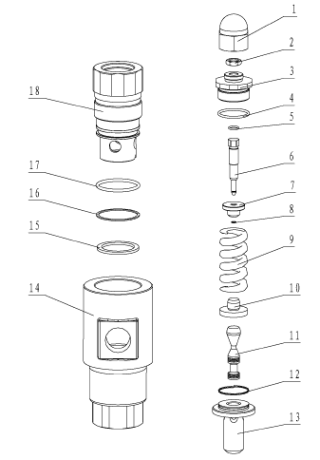
SN NAME ORDER NUMBER QUANTITY REMARKS
1 Covered nut 9162100014 1
2 Locking nut 9162100013 1
3 Valve border nut 9162100011 1
4 O-ring 5303002030 1 35.5×2.65
5 O-ring 5303000040 1 10×1.8
6 Adjusting bolt 9162100012 1
7 Up-spring beam 9162100010 1
8 Elastic retaining ring for rod 4206021360 1 6
9 Spring 9162100009 1
10 Down-spring beam 9162100006 1
11 Valve core 9162100005 1
12 Limit steel wire 9162100004 1 0.8×242
13 Valve core seat 9162100003 1
14 Valve body 9162100001 1
15 Sealing gasket 9162100015 1
16 Retaining ring 9162100007 1
17 O-ring 5303001270 1 48.7×3.55
18 Valve sleeve 9162100008 1

